**Blazor**

* Blazor can run C# code directly in web browser.
* Blazor is of two types 🡪 Blazor Web Assembly, Blazor Server App.
* Blazor Web Assembly runs compiled app, it’s dependencies & other Dot Net Runtime directly in the browser. Every thing the app needs is downloaded to the client browser from the server.

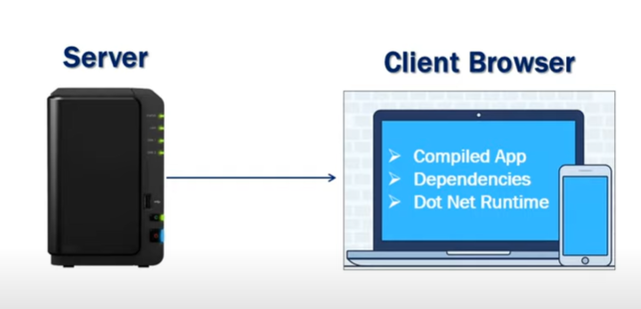

Blazor Web assembly can run entirely without connecting back to the server OR we can configure it to have web api calls or Signal R calls.

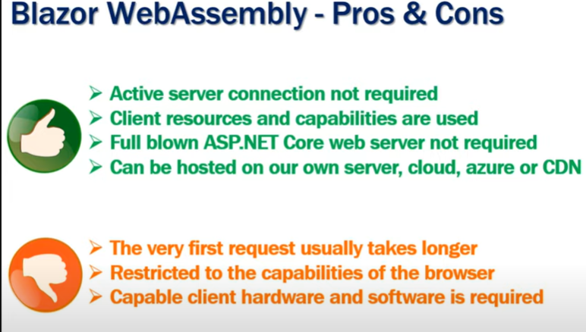

Blazor Server:

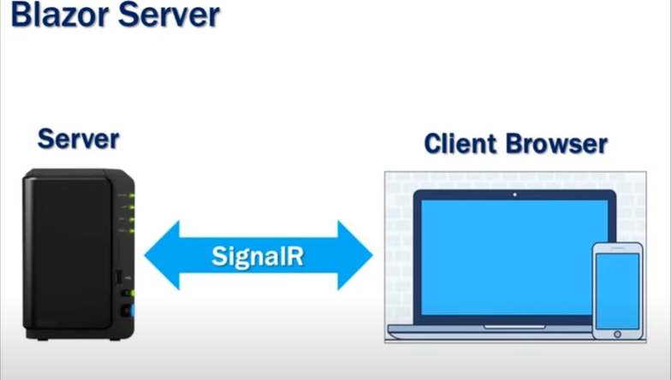

Instead of sending the entire app to the browser the blazers server app sends only required. The client makes Signal R connection back to the server when an event happens (ex: click event etc.,). After this only the difference of HTML will be sent back to the client from server.

